

MINI-PROJECT REPORT
ON
SMARTDROP
E-COMMERCE DELIVERY ROUTE OPTIMIZATION USING THE TRAVELLING SALESMAN PROBLEM (TSP)

Submitted in partial fulfillment of the requirements for the subject
DESIGN AND ANALYSIS OF ALGORITHM(DAA)

Submitted by
Janvi Rana(26MCD10109)
in partial fulfillment for the award of the degree of
Masters of Computer Applications
IN
Data science
Academic Session: 2026–2028

BONAFIDE CERTIFICATE

This is to certify that Ms. Janvi Rana, a student of Master of Computer Applications (MCA – Data Science), Semester I, at Chandigarh University, has successfully completed the mini-project entitled “SMARTDROP: E-Commerce Delivery Route Optimization Using the Travelling Salesman Problem (TSP)” as part of the academic requirements for the subject Design and Analysis of Algorithms (DAA) during the academic session 2026–2027.
To the best of our knowledge, this work has been carried out by the student under the guidance and supervision of the concerned faculty member.

SIGNATURE SIGNATURE
Name: Janvi Rana Name: Ms. Divyanshi Sharma
UID: 26MCD10109 Designation: Asst. Professor
Department: MCD-2A E- Code : E20677

Submitted for the project viva-voce examination held on: __________________

ACKNOWLEDGEMENT

I would like to express my sincere gratitude to my faculty guide for providing valuable guidance, support, and encouragement throughout the development of my mini-project, “SMARTDROP: E-Commerce Delivery Route Optimization Using the Travelling Salesman Problem (TSP).”
I am thankful to the Department of MCA(DS), Chandigarh University, for providing me with the opportunity to work on this project as part of the Design and Analysis of Algorithms (DAA) subject.
This project helped me understand the practical application of algorithms in solving delivery route optimization problems. I gained knowledge of the Nearest Neighbor, 2-Opt Optimization, and Brute Force algorithms, along with their implementation using Python. I also learned to develop a graphical user interface using Tkinter and visualize delivery routes using Matplotlib.
Finally, I would like to thank everyone who directly or indirectly supported me in completing this project successfully.

Janvi Rana
MCA (Data Science), Semester I
Chandigarh University

TABLE OF CONTENTS
S. No. | Contents | Page No.
1. | Aim | 6
2. | Objectives / Problem Definition | 6
3. | Programming Languages and Technologies Used | 7
4. | Block Diagram / System Design | 8
5. | Flowchart | 9
6. | Algorithms and Pseudocode | 10
7. | Implementation | 12
8. | Output and Results | 14
9. | Conclusion | 17
10. | Future Scope | 17
11. | Learning Outcomes | 17
12. | GitHub | 18

LIST OF FIGURES

Figure No. | Figure Title
Figure 1 | Block Diagram of SMARTDROP System
Figure 2 | Flowchart of the Proposed System
Figure 3 | SMARTDROP Application Main Dashboard
Figure 4 | Delivery Route Visualization

LIST OF TABLES

Table No. | Table Title
Table 1 | Programming Languages and Technologies Used
Table 2 | Comparison of Algorithms Used
Table 3 | Delivery Locations and Coordinates
Table 4 | Route Distance and Execution Time Comparison

1. AIM/OVERVIEW OF THE PROJECT
The aim of this project is to develop SMARTDROP, an E-Commerce Delivery Route Optimization System, using the Travelling Salesman Problem (TSP). The system uses Python to implement and compare three algorithms: Nearest Neighbour, 2-Opt Optimization, and Brute Force.
The project aims to determine an efficient route for a delivery person to visit multiple customer locations and return to the warehouse while minimizing the total travel distance. It also displays the calculated routes and algorithm results through a graphical user interface developed using Tkinter, with route visualization using Matplotlib.

2. OBJECTIVES
The main objectives of the SMARTDROP project are:
- To understand the Travelling Salesman Problem and its application in e-commerce delivery.
- To calculate distances between the warehouse and customer locations using Euclidean distance.
- To implement the Nearest Neighbour algorithm for finding a delivery route using a greedy approach.
- To implement the 2-Opt algorithm to improve an existing delivery route.
- To implement the Brute Force algorithm to examine possible customer visiting orders and find the optimal route for the given locations.
- To compare the algorithms based on total route distance and execution time.
- To develop a graphical user interface using Python Tkinter.
- To visualize the delivery route using Matplotlib.

3. PROBLEM DEFINITION
In e-commerce delivery, selecting an efficient route for visiting multiple customers is an important problem. An inefficient route may increase the total distance travelled and the time required to complete deliveries.
The Travelling Salesman Problem (TSP) addresses this challenge by finding a route that visits each customer exactly once and returns to the starting location while minimizing the total distance.
SMARTDROP solves a simplified version of this problem using a fixed warehouse and four customer locations. It calculates and compares routes using the Nearest Neighbour, 2-Opt Optimization, and Brute Force algorithms. The system displays the route distances, execution times, and visual representation of the routes.
The project demonstrates how different algorithmic approaches can be applied to delivery route optimization.

4. PROGRAMMING LANGUAGES AND TECHNOLOGIES USED
The SMARTDROP project is developed using Python and its libraries to implement delivery route optimization algorithms and display their results through a graphical interface.
4.1 Technologies Used
S. No. | Technology | Purpose
1. | Python | Implements the algorithms and project logic.
2. | Tkinter | Creates the graphical user interface (GUI).
3. | Matplotlib | Displays the delivery route graphically.
4. | itertools | Generates different customer visiting orders for the Brute Force algorithm.
5. | time / perf_counter | Measures the execution time of the algorithms.
6. | Euclidean Distance | Calculates the distance between delivery locations.

4.2 Hardware Requirements
Component | Requirement
Processor | Basic computer processor
RAM | 4 GB or above recommended
Storage | Sufficient space for Python and project files
Display | Standard monitor or laptop screen

4.3 Software Requirements
Component | Requirement
Operating System | Windows
Programming Language | Python
Code Editor | Visual Studio Code or another Python editor
GUI Library | Tkinter
Visualization Library | Matplotlib

4.4 Description
Python is used to implement the route optimization logic. Tkinter provides the application window, buttons, and result panels. Matplotlib is used to visualize the delivery route. The itertools module helps generate possible customer orders for the Brute Force algorithm, while perf_counter measures execution time.
These technologies work together to demonstrate and compare different approaches to solving the Travelling Salesman Problem.
5. BLOCK DIAGRAM / SYSTEM DESIGN
5.1 Block Diagram
The overall working of the SMARTDROP system is represented below.
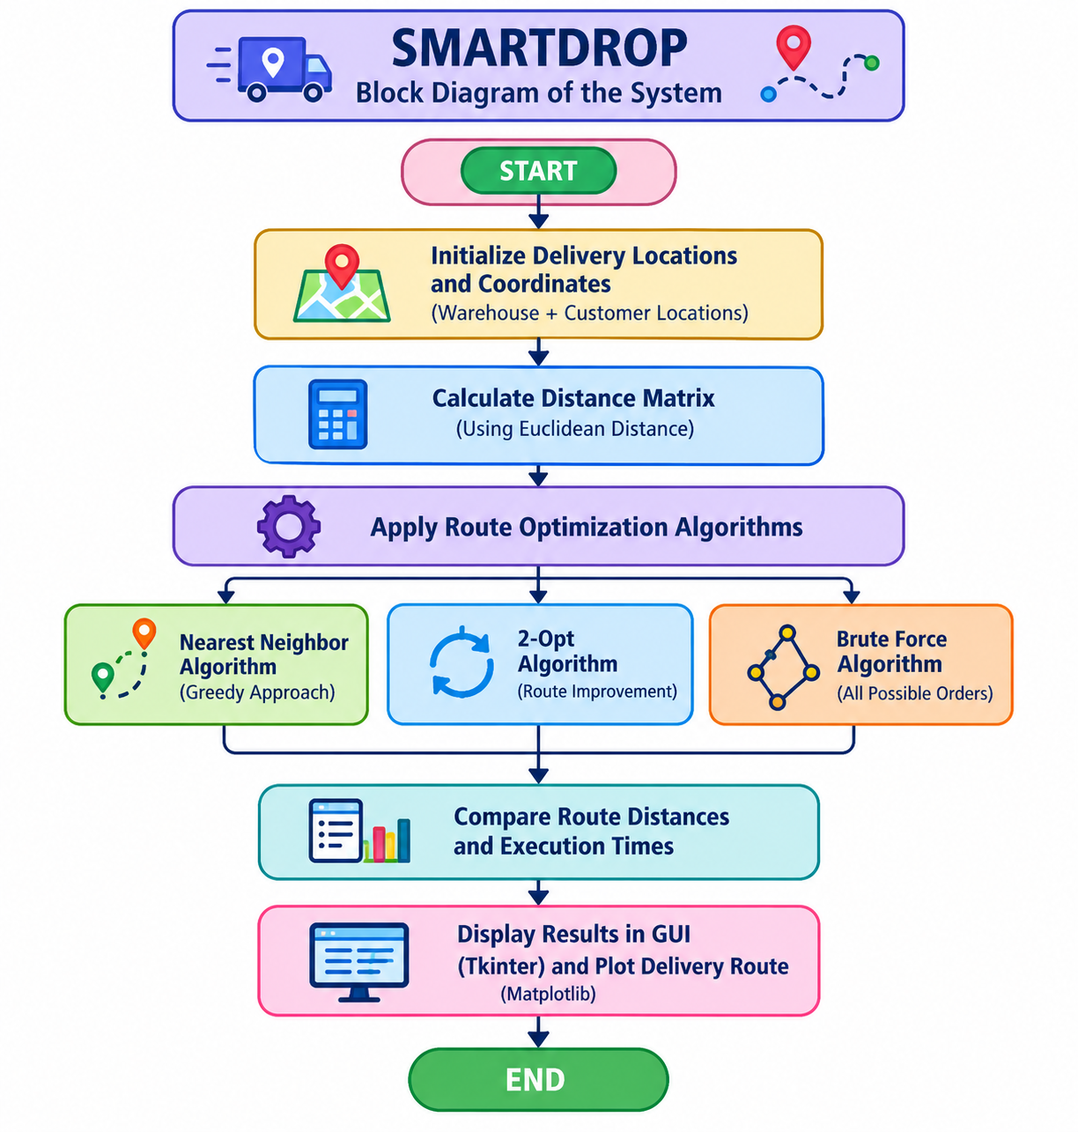
Figure 1. Block Diagram SmartDrop System
5.2 System Design
The SMARTDROP system consists of the following main components:
- Input Module: Stores the predefined coordinates of the warehouse and customer locations.
- Distance Calculation Module: Calculates the distances between locations using Euclidean distance.
- Algorithm Module: Executes the Nearest Neighbour, 2-Opt Optimization, and Brute Force algorithms.
- Comparison Module: Compares the total route distances and execution times produced by the algorithms.
- Graphical User Interface: Displays the algorithm results through a Tkinter-based dashboard.
- Route Visualization Module: Uses Matplotlib to represent the delivery route graphically.
5.3 Working Principle
First, the system initializes the warehouse and four customer locations. It calculates the distances between the locations and uses the selected algorithms to determine delivery routes. The resulting routes are evaluated using total distance and execution time. Finally, the application displays the results and provides a graphical representation of the delivery route.
- FLOWCHART OF SMARTDROP

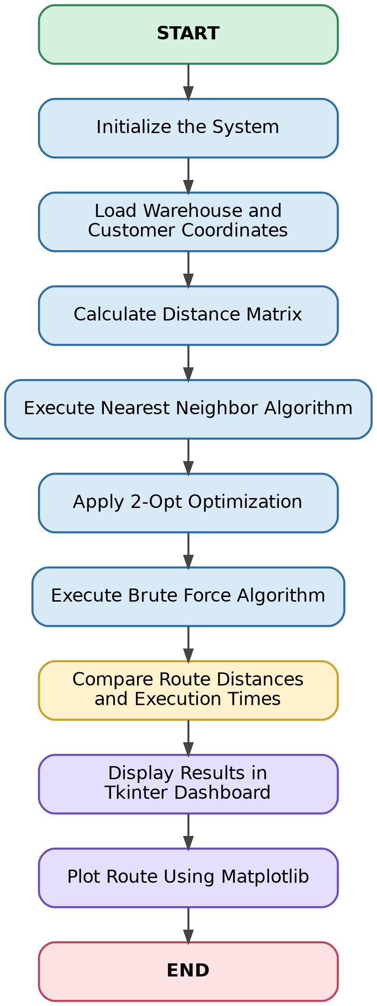
Figure 2. Flowchart of SmartDrop

- ALGORITHMS AND PSEUDOCODE
SMARTDROP uses three algorithms to calculate and compare delivery routes: Nearest Neighbor, 2-Opt Optimization, and Brute Force. Each algorithm follows a different approach to solving the Travelling Salesman Problem (TSP).
7.1 Nearest Neighbour Algorithm
Description
The Nearest Neighbour algorithm is a greedy algorithm. It starts from the warehouse and repeatedly selects the nearest unvisited customer until all customers have been visited. Finally, it returns to the warehouse.
Pseudocode
Algorithm: Nearest Neighbour
1. Start from the warehouse.
2. Mark the warehouse as visited.
3. Set the current location as the warehouse.
4. While unvisited customers remain:
a. Find the nearest unvisited customer.
b. Add that customer to the route.
c. Mark the customer as visited.
d. Update the current location.
5. Add the warehouse to the end of the route.
6. Calculate the total route distance.
7. Return the route and its distance.
Advantages
- Simple to understand and implement.
- Usually faster than checking every possible route.
- Suitable for finding a quick approximate solution.
Limitation
It does not guarantee the shortest possible route.

7.2 2-Opt Optimization Algorithm
Description
The 2-Opt algorithm improves an existing route by removing two edges and reconnecting the route in a different way. If the new route is shorter, the improvement is retained. This process continues until no further improvement is found.
In SMARTDROP, 2-Opt is used to improve a route generated by the Nearest Neighbor algorithm.
Pseudocode
Algorithm: 2-Opt Optimization
1. Take the initial route generated by Nearest Neighbor.
2. Calculate its total distance.
3. Select two edges in the route.
4. Reverse the section between the selected edges.
5. Calculate the new route distance.
6. If the new route is shorter:
Keep the improved route.
7. Repeat the process while improvements are possible.
8. Return the improved route and its distance.
Advantages
- Can improve an existing delivery route.
- Often produces shorter routes than the initial greedy solution.
Limitation
It does not guarantee the globally optimal route in every case.
7.3 Brute Force Algorithm
Description
The Brute Force algorithm examines all possible visiting orders of the customers. It calculates the total distance of each route and selects the route with the minimum distance.
Pseudocode
Algorithm: Brute Force
1. Generate all possible permutations of customer locations.
2. For each permutation:
a. Start the route at the warehouse.
b. Visit the customers in the permutation order.
c. Return to the warehouse.
d. Calculate the total route distance.
3. Compare the distance with the shortest distance found so far.
4. If the current route is shorter:
Update the shortest route.
5. After examining all permutations:
Return the shortest route and its distance.
Advantages
- Finds the optimal route for the given locations when all possible orders are examined.
- Provides a useful benchmark for comparing other algorithms.
Limitation
The number of possible routes increases factorially as the number of customers increases, making it inefficient for large problems.
7.4 Comparison of Algorithms
Feature | Nearest Neighbor | 2-Opt | Brute Force
Approach | Greedy | Local improvement | Exhaustive search
Main purpose | Find a quick route | Improve an existing route | Find the optimal route
Speed | Generally fast | Depends on iterations | Becomes very slow as locations increase
Guarantees optimal route? | No | Not generally | Yes, if all valid routes are examined
Used in SMARTDROP | Yes | Yes | Yes

8. IMPLEMENTATION
8.1 Introduction
SMARTDROP is a Python-based application designed to demonstrate delivery route optimization using the Travelling Salesman Problem (TSP). It uses three algorithms—Nearest Neighbor, 2-Opt Optimization, and Brute Force—to calculate and compare delivery routes.
The application provides a graphical user interface developed using Tkinter and displays route visualizations using Matplotlib.
8.2 Initialization of Delivery Locations
The system uses five predefined locations: one warehouse and four customers. Each location is represented by an X-coordinate and a Y-coordinate.
Location | X-Coordinate | Y-Coordinate
Warehouse | 10 | 10
Customer A | 20 | 15
Customer B | 35 | 25
Customer C | 25 | 40
Customer D | 10 | 45
These coordinates are used to calculate distances between the locations.
8.3 Distance Calculation
SMARTDROP uses Euclidean distance to calculate the distance between two locations.
The formula is:
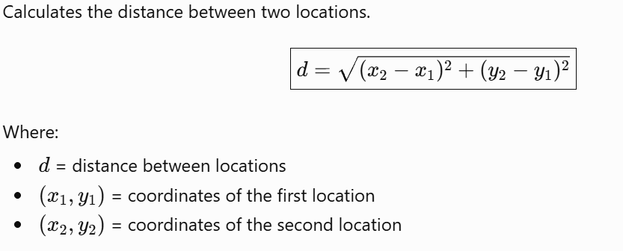
The calculated distances are used by the route optimization algorithms.
8.4 Implementation of Algorithms
A. Nearest Neighbour Algorithm
The algorithm starts from the warehouse and selects the nearest unvisited customer at each step. It continues until all customers have been visited and then returns to the warehouse.
B. 2-Opt Optimization Algorithm
The 2-Opt algorithm takes an initial route generated by the Nearest Neighbor algorithm and attempts to improve it by changing the order of locations. If a change reduces the total route distance, the improved route is retained.
C. Brute Force Algorithm
The Brute Force algorithm examines possible permutations of the customer locations. It calculates the total distance of each route and identifies the route with the minimum distance.

8.5 Graphical User Interface
The application uses Tkinter to provide an interactive dashboard. Its main components include:
- Header: Displays the SMARTDROP project title.
- Delivery Locations Panel: Shows the predefined warehouse and customer locations.
- Calculate Best Route Button: Runs the route calculations and displays the algorithm results.
- View Route Graph Button: Displays the graphical representation of the delivery route.
- Algorithm Result Cards: Present the calculated route distances and execution times.
- Delivery Plan Panel: Displays the delivery order and route information.
- Exit Button: Closes the application.
8.6 Route Visualization
Matplotlib is used to visualize the delivery route. The graph represents the warehouse and customer locations as points and connects them according to the calculated visiting order.
The visualization helps users understand the route followed by the delivery person, including the return to the warehouse.
8.7 Performance Measurement
The execution time of each algorithm is measured using a high-resolution performance timer. The total route distance and execution time are then displayed for comparison.
The results depend on the computer's performance and the execution conditions. Since the project uses a small, fixed set of locations, the algorithms can be compared on the same input data.

9. OUTPUT AND RESULTS
9.1 Application Output
The SMARTDROP application provides a graphical dashboard for calculating and comparing delivery routes. The interface displays the delivery locations, algorithm results, route information, and options for viewing the delivery route graph.
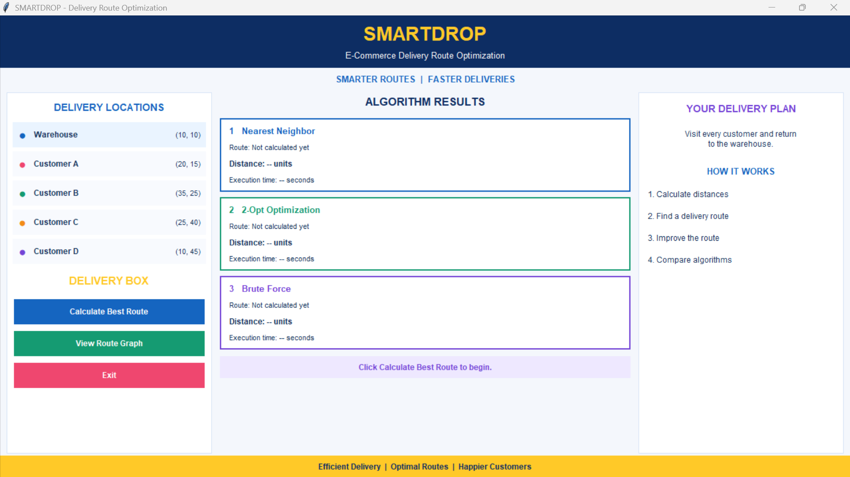
Figure 3: SMARTDROP Main Dashboard
9.2 Delivery Route Visualization
The application uses Matplotlib to display the warehouse and customer locations on a graph. The locations are connected in the calculated visiting order, and the route returns to the warehouse after visiting all customers.
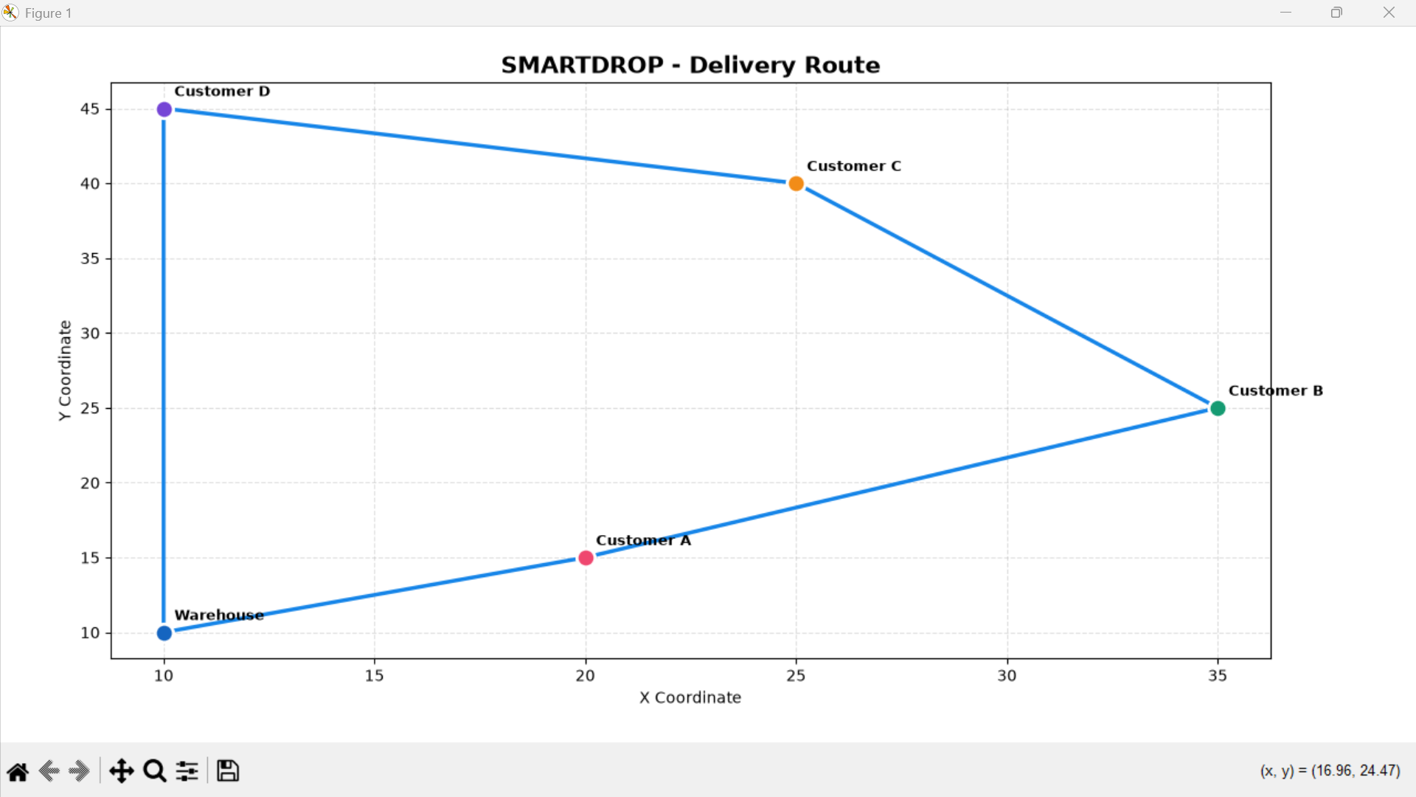
Figure 4: Delivery Route Visualization
9.3 Results of Route Optimization
The application compares three algorithms:
- Nearest Neighbour: Constructs a route by repeatedly choosing the nearest unvisited customer.
- 2-Opt Optimization: Attempts to improve the initial route by rearranging parts of it.
- Brute Force: Examines all possible customer visiting orders to identify the minimum-distance route.
For the five predefined locations, the algorithms have produced a route with a total distance of approximately 98.05 distance units in the observed project output.
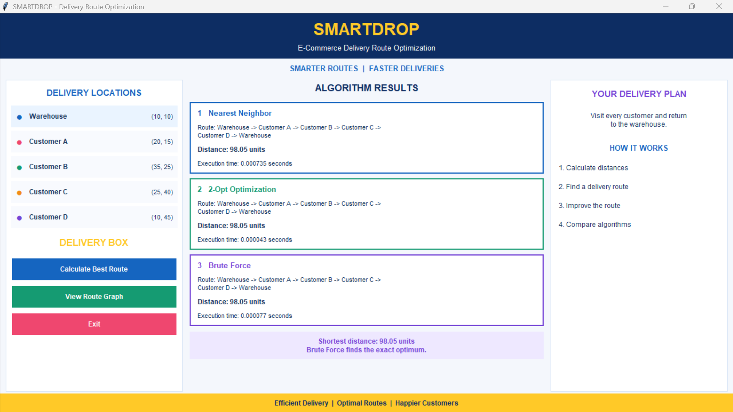
Figure 5: Route Optimization
9.4 Comparison of Algorithms
Algorithm | Route Distance | Execution Time
Nearest Neighbour | Approximately 98.05 units | As displayed by the application
2-Opt Optimization | Approximately 98.05 units | As displayed by the application
Brute Force | Approximately 98.05 units | As displayed by the application

9.5 Result Analysis
The observed results show that all three algorithms can produce the same delivery route distance for the selected locations. However, they use different approaches to find that route.
Nearest Neighbour provides a quick greedy solution, 2-Opt attempts to improve an existing route, and Brute Force checks all possible customer orders to find the shortest route.
Although the distances are equal in this example, execution times may differ. The results demonstrate the importance of comparing algorithm efficiency as well as route quality.
10. CONCLUSION
The SMARTDROP project demonstrates delivery route optimization using the Travelling Salesman Problem (TSP). It implements three algorithms: Nearest Neighbour, 2-Opt Optimization, and Brute Force, using Python, Tkinter, and Matplotlib.
The project compares route distances and execution times and displays routes graphically. It provides practical knowledge of algorithm design, performance analysis, GUI development, and problem-solving.
11. FUTURE SCOPE
- Allow users to enter customer locations dynamically.
- Integrate digital maps for real-world route planning.
- Consider live traffic conditions.
- Support more customer locations.
- Add advanced optimization algorithms.
- Support multiple delivery persons.
12. LEARNING OUTCOMES
- Understood the Travelling Salesman Problem (TSP).
- Learned to implement three route optimization algorithms.
- Understood greedy, local-search, and exhaustive-search approaches.
- Learned Euclidean distance calculation.
- Compared algorithms using distance and execution time.
- Developed a GUI using Tkinter.
- Visualized routes using Matplotlib.
- Improved programming and problem-solving skills.
13. GitHub

